Reverse Problem Investigation Report  
2019202052

Kim Ho-sung  
inverse problem  
- General ideas on reverse issues, including linear and nonlinear problems  
The inverse problem also includes the inverse function and the inverse matrix, let's first look at the inverse function.

1.a linear problem  
A typical example is the inverse matrix.  
The definition of inverse matrix is as follows.  
A*A^-1 = I (elevation function)  
Procedure for solving the inverse matrix is as follows.  
Ax = b  
=> A^-1 * A x = A^-1 b  
=> Ix = A^-1*b  
=> x = A^-1*b.   
What can be used here is assumed that there is an answer to the expression, and that there is a linear expression with the same number of expressions and unknowns. Usually, after using the LU decomposition method as a process of pooling, some methods can be used to obtain n unknowns using forward and backward interventions, but some methods can be obtained directly by x = A-1-1*b (but only when the inverse is not det(A) = 0).

2. Nonlinear problem  
A typical example is the inverse function.  
The inverse function is a function obtained by reversing a variable and its value. That is, in the reaction rules of the inverse function, the original output value corresponds to the original input value. Under the conditions of the inverse function, the inverse matrix can only exist if all x of the original function is a one-to-one response to y. (However, not all y's need to be a one-to-one response to x.)  
The properties of the inverse function are as follows.  
1. (f^-1∙f)x =f^-1(f(x) = f^-1(y) = x  
(It is an antisymmetric function for x.)  
2. (f^-1∙f)y =f^-1(f(y) = f^-1(x) = y  
(It is an antisymmetric function for y.)

If you use differentials, the most representative method of obtaining values by using inverse functions, the following is the case. If the inverse function is used when undivided, use the following expression. dy/(dx ) = 1/(dx/dy). If the desired function satisfies the one-to-one response, the inverse function f(x) is   
When y = ∜(x+1), use 1/(dx/dy). First, if you modify a given expression, it is y^4=x+1.  
If the two sides are differential with respect to y,  
Y^3 = dx/dy and di/dx is 1/4yyy.  
In other words, functions that contain routes that are difficult to calculate by utilizing inverse functions can be solved relatively easily.

- Theory of linear inverse problem  
The reverse problem is the reverse of all actions to infer the desired answer by using the data and inferring the problem in reverse. On the contrary, it is said to solve the problem by looking at the problem and inferring the answer.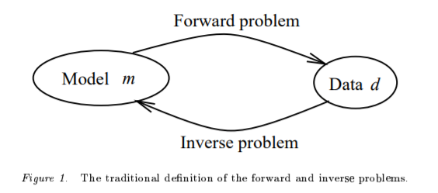

In addition, the inverse matrix should be used to obtain an unknown number called x.  
Ax = b  
=> A^-1 * A x = A^-1 b  
=> Ix = A^-1*b  
=> x = A^-1*b.

If this is substituted for the matrix, the following figure is shown.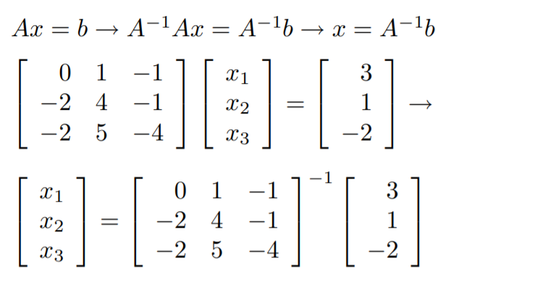

- Example of a linear reverse problem

A typical type of linear inverse problem is solving the inverse matrix. In the case of inverse matrix problems, there are a lot of pdf files we send together, so let's pick one of them and solve it. (You can see how much we know about the concept of inverse matrix.)

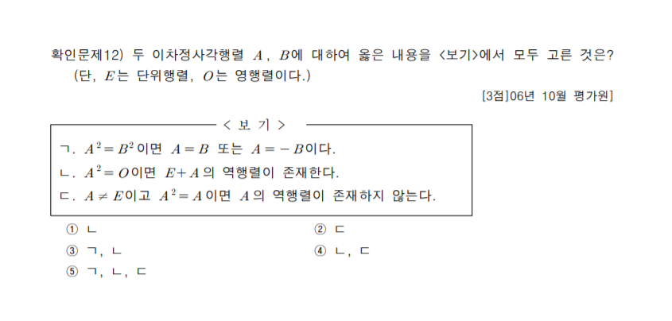

The answer is number 4, if A is $\begin{matrix}1 & 1 \\ -1 & -1\end{matrix}$ for the first line, A^2 is 0, but A is not

참조 문헌

<http://www.geo.uu.nl/~seismain/pdf/springer99-inv.pdf>

<http://www.cv.titech.ac.jp/~hiro-lab/lecture/civil_analy/09note10.pdf>

<http://www.ipgp.fr/~tarantola/Files/Professional/Books/InverseProblemTheory.pdf>

<http://web.gps.caltech.edu/classes/ge193.old/lectures/Lecture1.pdf>

[https://projects.ncsu.edu/crsc//events/ugw06/presentations/jlsloan/pres5.pdf](https://projects.ncsu.edu/crsc/events/ugw06/presentations/jlsloan/pres5.pdf)

<https://www.youtube.com/watch?v=ABH5KN5DTuc>  
<https://ko.wikipedia.org/wiki/%EC%97%AD%ED%95%A8%EC%88%98>

<https://darkpgmr.tistory.com/104>

<http://blog.naver.com/PostView.nhn?blogId=dalsapcho&logNo=20132039264&parentCategoryNo=&categoryNo=27&viewDate=&isShowPopularPosts=false&from=postView>

<https://bhsmath.tistory.com/233>

<https://cae.seoultech.ac.kr/num/m10_LuDecomposition.pdf>